**PIZZA SALES SQL QUERIES**

**A. KPI’s**

**1. Total Revenue:**

Select cast(sum(Total_price) as decimal(10,2)) as Total_Revenue from pizza_sales;

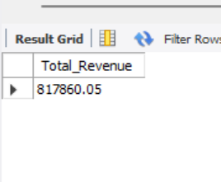

**2. Average Order Value**

select sum(total_price)/count(distinct(order_id)) as Avg_order_value from pizza_sales;

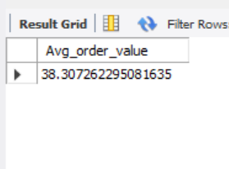

**3. Total Pizzas Sold**

select sum(quantity) as Total_pizzas_sold from pizza_sales;

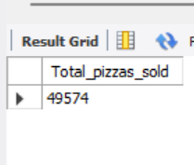

**4. Total Orders**

Select count(distinct(order_id)) as Total_orders from pizza_sales;

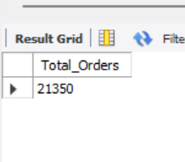

**5. Average Pizzas Per Order**

select cast(sum(quantity)/count(distinct(order_id)) as decimal (10,2)) as Avg_pizzas_per_order from pizza_sales;

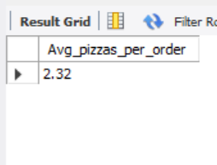

**D. % of Sales by Pizza Category**

select pizza_category, cast(sum(total_price) as decimal (10,2)) as Total_Revenue, cast(sum(total_price) * 100/ (select sum(total_price) from pizza_sales) as decimal(10,2)) as PCT from pizza_sales

group by pizza_category;

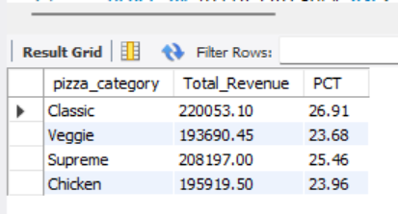

**E. % of Sales by Pizza Size**

select pizza_size, cast(sum(total_price) as decimal (10,2)) as Total_Revenue,

cast(sum(total_price) * 100/ (select sum(total_price) from pizza_sales) as decimal (10,2)) as PCT from pizza_sales

group by pizza_size;

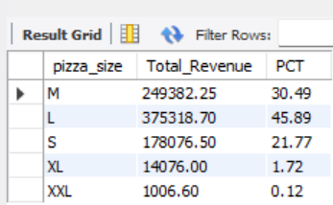

**F. Total Pizzas Sold by Pizza Category**

select pizza_category, sum(quantity) as Total_pizza_sold from pizza_sales

group by pizza_category

order by pizza_category asc;

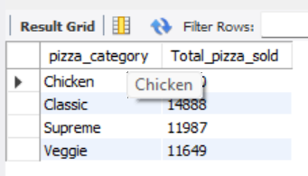

**G. Top 5 Pizzas by Revenue**

select pizza_name,sum(total_price) as Total_Revenue from pizza_sales

group by pizza_name

order by Total_Revenue desc limit 5;

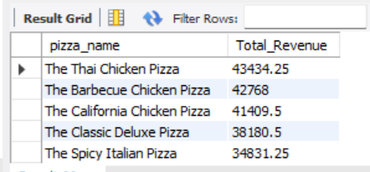

**H. Bottom 5 Pizzas by Revenue**

select pizza_name,sum(total_price) as Total_Revenue from pizza_sales

group by pizza_name

order by Total_Revenue limit 5;

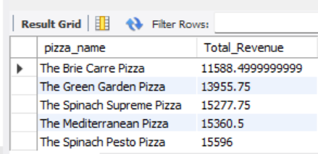

**I. Top 5 Pizzas by Quantity**

select pizza_name,sum(quantity) as Total_Quantity from pizza_sales

group by pizza_name

order by Total_Quantity desc limit 5;

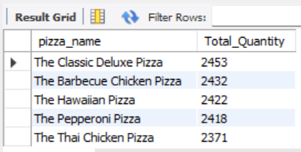

**J. Bottom 5 Pizzas by Quantity**

select pizza_name,sum(quantity) as Total_Quantity from pizza_sales

group by pizza_name

order by Total_Quantity limit 5;

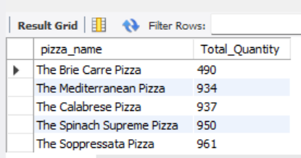

**K. Top 5 Pizzas by Total Orders**

select pizza_name, count(distinct(order_id)) as Total_Orders from pizza_sales

group by pizza_name

order by Total_Orders desc limit 5;

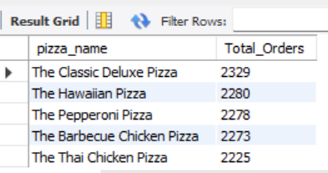

**L. Bottom 5 Pizzas by Total Orders**

select pizza_name, count(distinct(order_id)) as Total_Orders from pizza_sales

group by pizza_name

order by Total_Orders limit 5;

